ShopNest PowerBI Capstone

Sumit Samantara

Capstone project

Introduction:

In this project we have give our own observations from Nexusgoods store data

with help of PowerBI.

Insights:

1. Question Statement:

Identify the rating distribution in the Shop_Nest dataset, showcasing ratings categorized as Excellent, Very Good, Good, Bad, and Very Bad, along with corresponding orders.

Visualization:

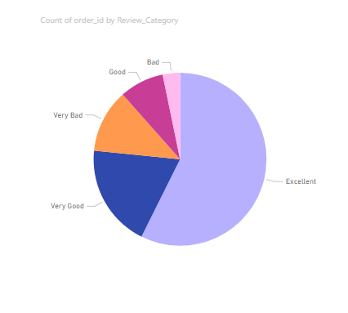

Review Distribution

Explanation:

From the figure we can clearly see that almost 58% of Total customers given ‘5 star’ Rating as Review where as 20% customers given ‘4 star’ and 10% given ‘3 star’. Which is normal for product-based company.

1. Question Statement:

What are the top 10 and bottom 18 most popular product categories in the ShopNest dataset ? Please list them based on the number of orders.

Visualization:

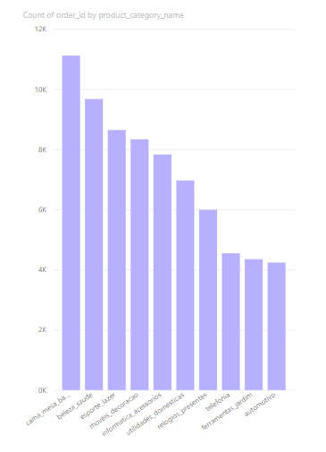

Top 10 Product Categories

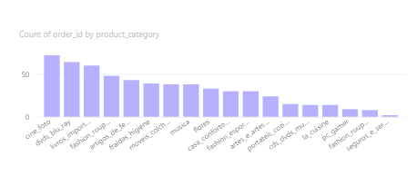

Bottom 18 Product Categories

Explanation:

In Upper Visual Top 10 and Bottom 18 popular product categories are shown. While the top 10 are receiving orders in thousands the bottom categories are ordered below 60.

1. Question Statement:

List the total number of active sellers by yearly and monthly.

Visualization:

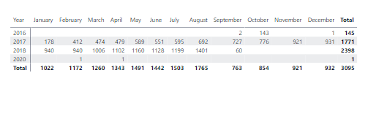

Active sellers w.r.t different month and year

Explanation:

The Number of Active Sellers are highest in August and Lowest in September.

1. Question Statement:

Which payment methods are most commonly used by ShopNest customers?

Visualization:

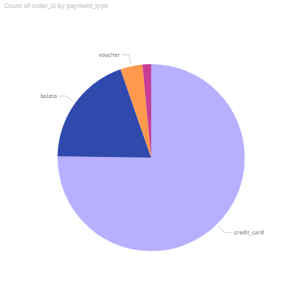

Payment method Distribution

Explanations:

75% of Customers paid through Credit Card we can use this info to attract customer or give some offers to react customer satisfaction and make them loyal customers.

1. Question Statement:

Identify the product category. wise profit margin using the formula

Visualization:

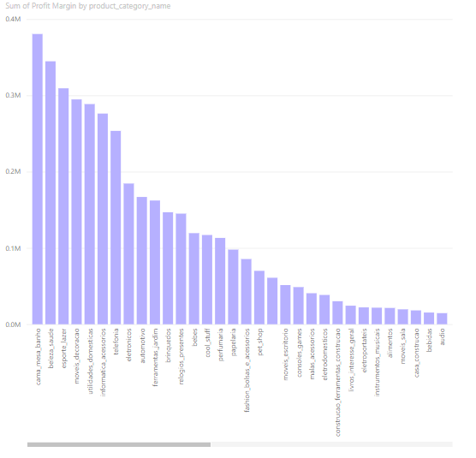

Profit Distribution w.r.t Product Category

Explanation:

Product Category wise profit is shown on this figure.

1. Question Statement:

Determine the monthly payments made by customers using credit cards.

Visualization:

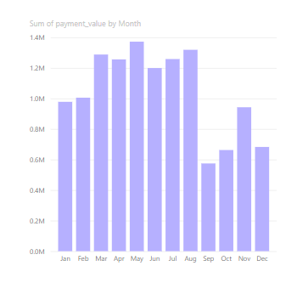

Credit Card Payment distribution w.r.t diff months

Explanation:

Figure shows payment distribution through months using Credit Cards. Which Suddenly Falls down on September after being the 2nd highest in August.

1. Question Statement:

Identify sellers categorized by city, excluding cities starting with the letters S and B.

Visualization:

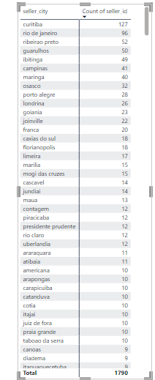

Sellers of different cities

Explanation:

Figure Shows the number of Sellers came from different cities excluding the cities starts with S and B.

1. Question Statement:

Create a dynamic visual that compares the number of delayed orders to the number of orders received earlier for each month. Utilize the drill through the cross-report feature to provide a detailed analysis of late and on-time deliveries.

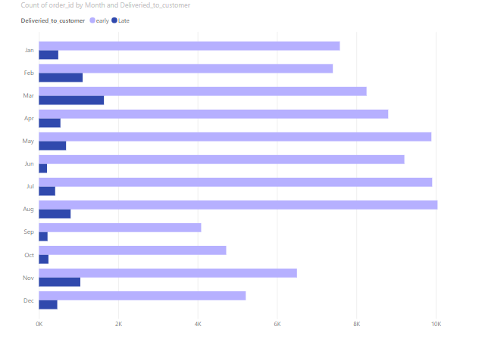

Comaparision Between Early/on-time and Late Deliveries

Explanation:

Upper figure shows comaprition of number of order delivered before time and after the estimated time.

For some reason March month shows highest rate late deliveries almost 20% of the early or ontime deliveries.

September,october and June shows the lowest rate of late deliveries. But September and October Order rate is low so June month’s performance is best gives the lowest rate of late deliveries with respect to early or on-time deliveries.

Company should pay attention to increase the number of active sellers during end of the year generally after August. Because reduction in active seller leads to shortage of products or “out of stock” products due to which orders and also payments during this peroid drastically decrases.During this period company may also lose some loyal customers.